**Flyweight pattern**

Flyweight pattern is primarily used to reduce the number of objects created and to decrease memory footprint and increase performance. This type of design pattern comes under structural pattern as this pattern provides ways to decrease object count thus improving the object structure of application.

Flyweight pattern tries to reuse already existing similar kind objects by storing them and creates new object when no matching object is found. We will demonstrate this pattern by drawing 20 circles of different locations but we will create only 5 objects. Only 5 colors are available so color property is used to check already existing *Circle* objects.

Implementation

We are going to create a *Shape* interface and concrete class *Circle* implementing the *Shape* interface. A factory class *ShapeFactory* is defined as a next step.

*ShapeFactory* has a *HashMap* of *Circle* having key as color of the *Circle* object. Whenever a request comes to create a circle of particular color to *ShapeFactory*, it checks the circle object in its *HashMap*, if object of *Circle* found, that object is returned otherwise a new object is created, stored in hashmap for future use, and returned to client.

*FlyWeightPatternDemo*, our demo class, will use *ShapeFactory* to get a *Shape* object. It will pass information (*red / green / blue/ black / white*) to *ShapeFactory* to get the circle of desired color it needs.

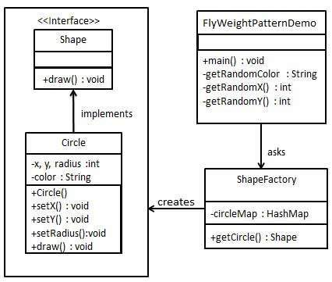

Step 1

Create an interface.

*Shape.java*

public interface Shape {

void draw();

}

Step 2

Create concrete class implementing the same interface.

*Circle.java*

public class Circle implements Shape {

private String color;

private int x;

private int y;

private int radius;

public Circle(String color){

this.color = color;

}

public void setX(int x) {

this.x = x;

}

public void setY(int y) {

this.y = y;

}

public void setRadius(int radius) {

this.radius = radius;

}

@Override

public void draw() {

System.out.println("Circle: Draw() [Color : " + color + ", x : " + x + ", y :" + y + ", radius :" + radius);

}

}

Step 3

Create a factory to generate object of concrete class based on given information.

*ShapeFactory.java*

import java.util.HashMap;

public class ShapeFactory {

// Uncomment the compiler directive line and

// javac *.java will compile properly.

// @SuppressWarnings("unchecked")

private static final HashMap circleMap = new HashMap();

public static Shape getCircle(String color) {

Circle circle = (Circle)circleMap.get(color);

if(circle == null) {

circle = new Circle(color);

circleMap.put(color, circle);

System.out.println("Creating circle of color : " + color);

}

return circle;

}

}

Step 4

Use the factory to get object of concrete class by passing an information such as color.

*FlyweightPatternDemo.java*

public class FlyweightPatternDemo {

private static final String colors[] = { "Red", "Green", "Blue", "White", "Black" };

public static void main(String[] args) {

for(int i=0; i < 20; ++i) {

Circle circle = (Circle)ShapeFactory.getCircle(getRandomColor());

circle.setX(getRandomX());

circle.setY(getRandomY());

circle.setRadius(100);

circle.draw();

}

}

private static String getRandomColor() {

return colors[(int)(Math.random()*colors.length)];

}

private static int getRandomX() {

return (int)(Math.random()*100 );

}

private static int getRandomY() {

return (int)(Math.random()*100);

}

}

Step 5

Verify the output.

Creating circle of color : Black

Circle: Draw() [Color : Black, x : 36, y :71, radius :100

Creating circle of color : Green

Circle: Draw() [Color : Green, x : 27, y :27, radius :100

Creating circle of color : White

Circle: Draw() [Color : White, x : 64, y :10, radius :100

Creating circle of color : Red

Circle: Draw() [Color : Red, x : 15, y :44, radius :100

Circle: Draw() [Color : Green, x : 19, y :10, radius :100

Circle: Draw() [Color : Green, x : 94, y :32, radius :100

Circle: Draw() [Color : White, x : 69, y :98, radius :100

Creating circle of color : Blue

Circle: Draw() [Color : Blue, x : 13, y :4, radius :100

Circle: Draw() [Color : Green, x : 21, y :21, radius :100

Circle: Draw() [Color : Blue, x : 55, y :86, radius :100

Circle: Draw() [Color : White, x : 90, y :70, radius :100

Circle: Draw() [Color : Green, x : 78, y :3, radius :100

Circle: Draw() [Color : Green, x : 64, y :89, radius :100

Circle: Draw() [Color : Blue, x : 3, y :91, radius :100

Circle: Draw() [Color : Blue, x : 62, y :82, radius :100

Circle: Draw() [Color : Green, x : 97, y :61, radius :100

Circle: Draw() [Color : Green, x : 86, y :12, radius :100

Circle: Draw() [Color : Green, x : 38, y :93, radius :100

Circle: Draw() [Color : Red, x : 76, y :82, radius :100

Circle: Draw() [Color : Blue, x : 95, y :82, radius :100